# Purpose

* Quickly save premade UTDF worksheets pre-made in excel
* The UTDF csv sheets can me imported into synchro to quickly input volume, PHF, truck% data

# Requirements

1. In the volume forecasting excel spreadsheet, there **MUST** be a tab named ‘**UTDF**’.
2. Everything to the left of **UTDF** is your volume calcs. Everything to the right of **UTDF** are your “premade UTDF” sheets to be saved into csv format.

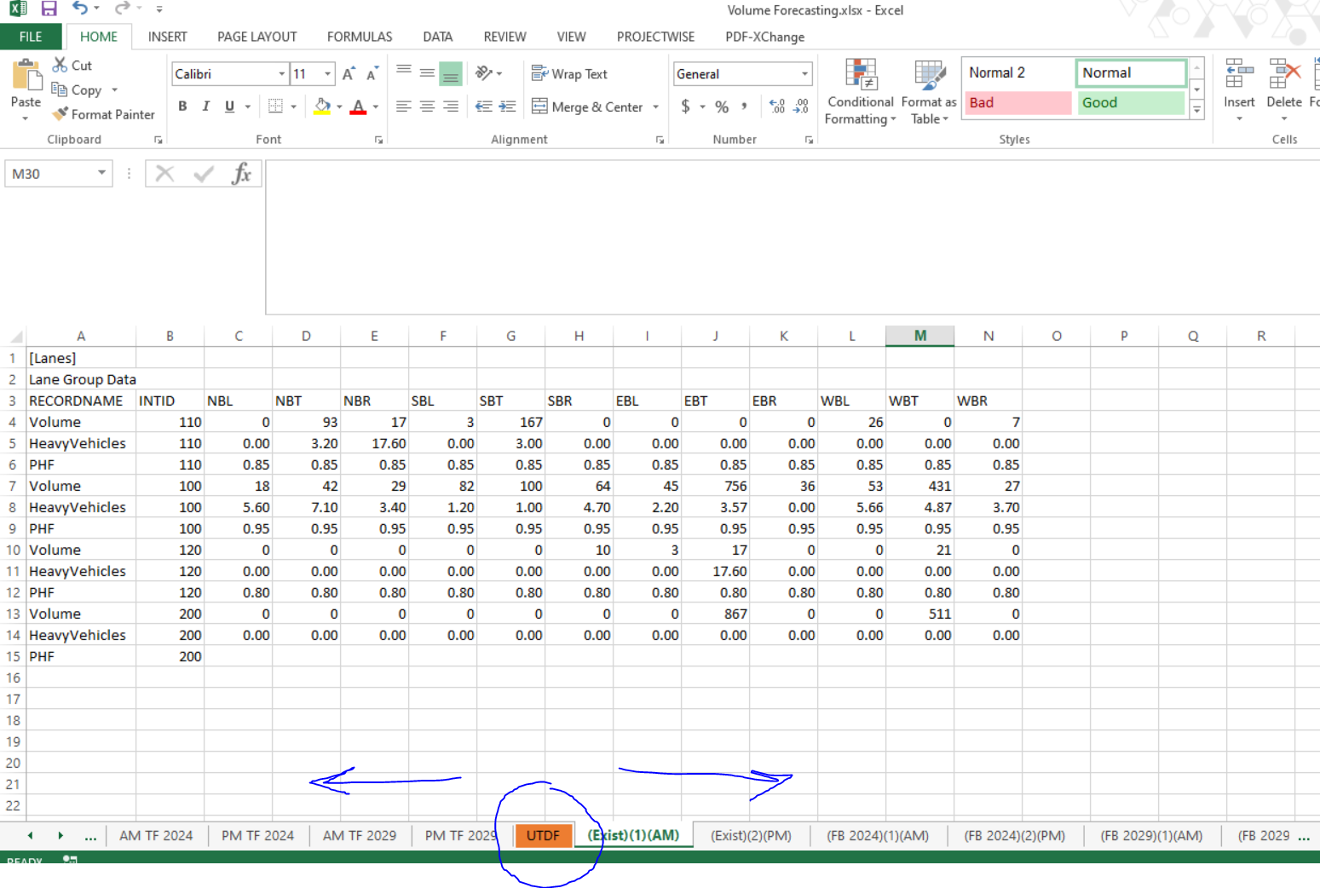

1. **NO ADDITIONAL WORK SHEETS SHOULD PROCEED** the premade UTDFs. This is crucial for the python script.
   1. The python script saves every worksheet after ‘UTDF’ so only put premade UTDFs csv worksheets to save processing time.
2. Tab names can be anything you want **UNLESS** you are using these csv files for Eric Stewart’s Inkscape python script as well. If so, these tab names must be in his prescribed format. For example: “(Exist)(1)(AM)”, “(Exist)(2)(PM)”
   1. This is crucial for Eric’s Python script for Inkscape figures.
   2. Refer to his “read me” for more details
   3. A version of his script is provided in the main folder directory
3. “INTID” in cell B3 refers to the Synchro node #s and Inkscape object label name. Make sure these numbers match between the csv, Synchro, and Inkscape

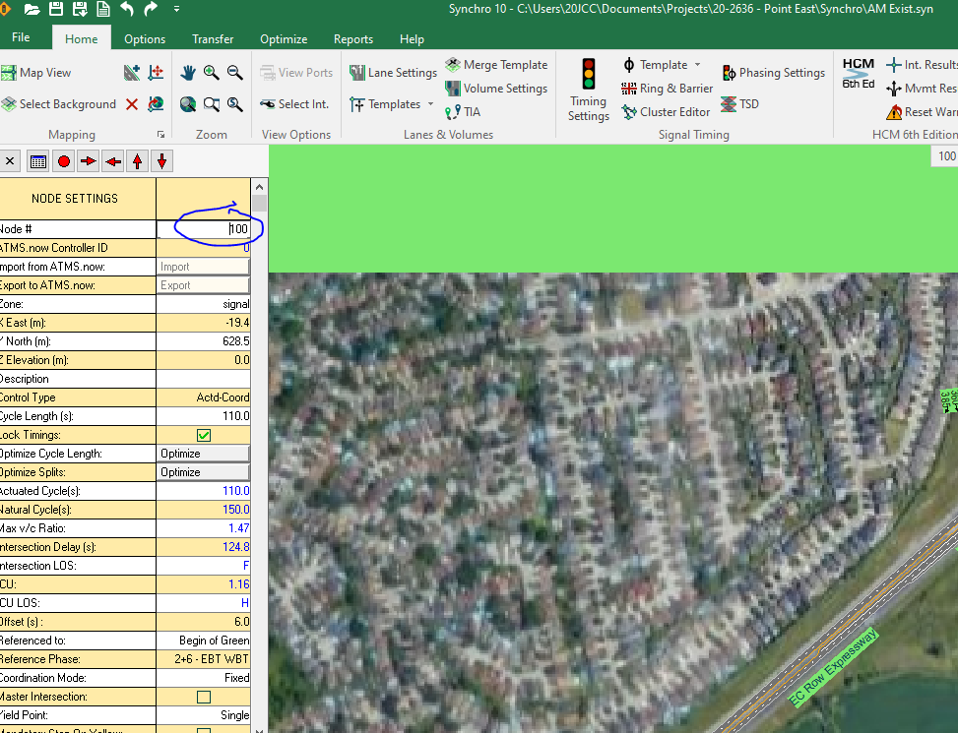

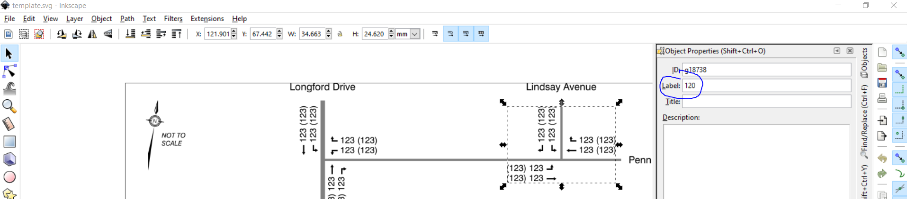

*\*\* examples are not from the same project. Just for illustration purposes*

# How it works (overview)

* Rounds ‘Volume’ to nearest integer or nearest 5
* Rounds ‘PHF’ to 2 digits
* Rounds ‘HeavyVehicles’ to 0 decimal places. These numbers must be ‘general/number format in excel. Must not be in % format. For example: 3.2% will not work. Must be 3.2
* After you run the script, it will ask for full directory of volume spreadsheet, as well as its name.

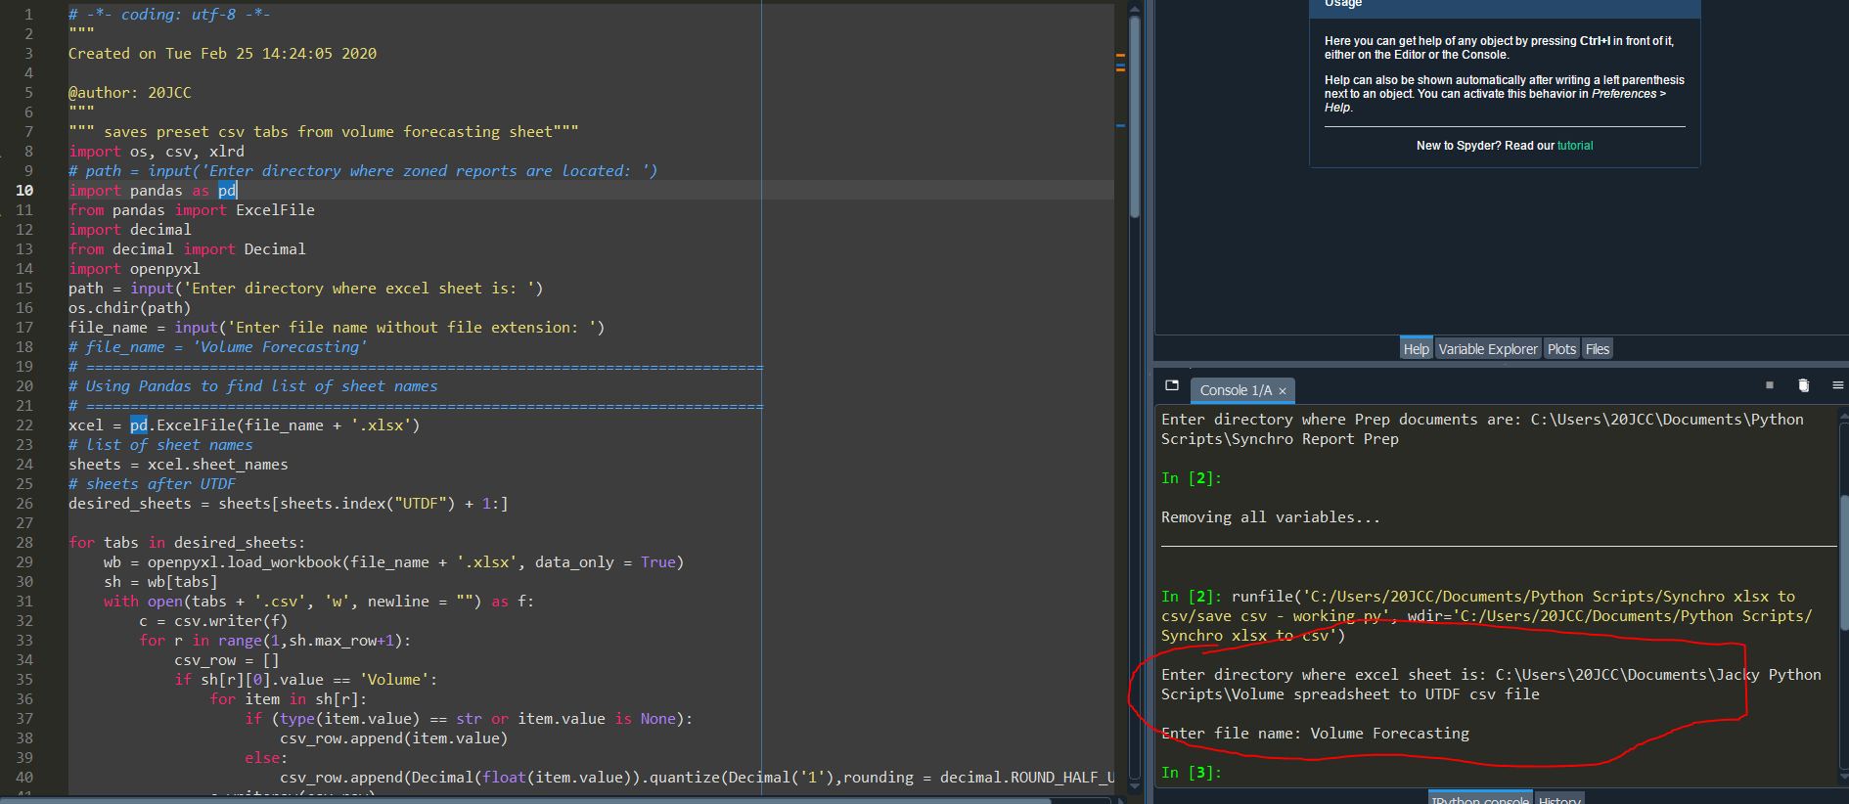

# Outputs

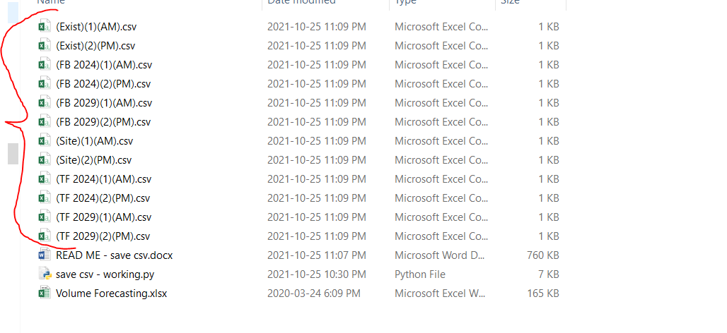

# More on UTDF

* Save synchro as csv to see what other information can be imported into Synchro via csv file